Improving Weather Forecast Accuracy Using Hybrid Machine Learning Algorithms

Naga Charitavya Madala Sai Durga Saradhi Pranu Deepak Tallapudi Venkata Srikari Malladi
Department of CSE, Department of CSE, Department of CSE,
SRM University-AP, SRM University-AP, SRM University-AP,
nagacharitavya_m@srmap.edu.in deepak_tallapudi@srmap.edu.in venkatasrikari_m@srmap.edu.in

Durga Mahesh Muthinti Srilatha Tokala Murali Krishn Enduri
Department of CSE Department of CSE Department of CSE
SRM University-AP, SRM University-AP, SRM University-AP
durgamahesh_muthinti@srmap.edu.in srilatha_tokala@srmap.edu.in muralikrishna.e@srmap.edu.in

Abstract—Weather prediction, particularly for rainfall, temperature and relative humidity (RH%), is critical for climate-sensitive industries such as agriculture and disaster relief. This paper introduces a predictive modeling framework based on a range of machine learning (ML) methods. In addition, hybrid models such as Catboost-Logistic Regression, XGboost-k-Nearest Neighbors (KNN) and Gaussian Process-Decision Tree have been investigated to improve prediction accuracy. Using a 10-year Gannavaram dataset, we focus on multi-label classifications (2 to 5 labels) of weather characteristics such as rainfall, temperature, and RH%. Notably, the Gaussian Process consistently predicted rainfall with 100% accuracy, while hybrid models such as Catboost-Logistic Regression and XGBoost-KNN performed well across a variety of criteria. The combination of these hybrid models and standalone ML algorithms has considerably increased the resilience of weather forecasting. Our research highlights the effectiveness of combining machine learning models to improve predictive accuracy, offering a valuable contribution to real-time weather prediction systems.
Keywords- Weather prediction, Rainfall, Temperature, Relative Humidity (RH%), Machine Learning, Hybrid Models, Catboost, XGBoost, Gaussian Process, Multi-label Classification, Gannavaram Dataset, Predictive Modeling, Real-time Weather Forecasting.

Introduction
Accurate weather forecasting is essential for sectors like agriculture, disaster management, and environmental planning, where fluctuations in weather can present significant risks. While generally reliable, traditional numerical weather prediction models often struggle to incorporate large and complex datasets, such as multi-year climate records, which can hinder their forecasting accuracy [1]. Machine learning (ML) has emerged as a potent solution for enhancing weather prediction, excelling at analyzing historical data, identifying patterns, and making accurate predictions, even when weather parameters exhibit non-linear relationships [2]. The role of ML in examining global climate changes, demonstrates its ability to improve climate data interpretation and simulations, while emphasizing the increasing use of ML in climate science, enhancing Earth system modeling and forecasting capabilities [3]. To enhance the accuracy Artificial Neural Networks (ANNs) and Singular Spectrum Analysis (SSA) to predict water consumption, discovering that SSA effectively reduced noise while the optimized ANN [4]. The significance of agriculture in countries like India, where it constitutes 16% of GDP, investigating the application of Long Short-Term Memory (LSTM) networks for more precise weather forecasting and addressing the limitations of conventional methods due to the unpredictable nature of weather. Machine learning models with a limited feature set to forecast rainfall based on relative humidity, vapor pressure, and temperature, revealing that vapor pressure had a predictive relevance of 0.89, while temperature's effect was captured through its correlation with other variables [5]. This study focuses on both standalone and hybrid ML models to enhance multi-label weather classification accuracy, utilizing a 10-year dataset from Gannavaram and evaluating models such as Decision Tree, Random Forest, Catboost, and XGBoost, alongside hybrid models like Gaussian Process, k-Nearest Neighbors (KNN), and Logistic Regression. Hybrid approaches, including Catboost-Logistic regression and Gaussian process Decision Tree, demonstrated significant improvements, particularly in rainfall prediction, with the Gaussian Process achieving an accuracy of 100%. This research adds to the growing body of evidence supporting the effectiveness of ML for achieving more precise and reliable weather forecasting.
In this work, we propose a weather prediction framework using standalone and hybrid machine learning models. Our work highlights: Gaussian Process for top rainfall prediction accuracy, catboost + Logistic Regression for reliable weather parameter performance, XGBoost + KNN for effective multi-label classification of temperature and humidity, and Gaussian Process + Decision Tree for improved real-time rainfall forecasting. The rest of this paper is organized as follows: Sec. II reviews related works, Sec. III describes materials and methodology, Sec. IV presents the dataset, Sec. V discusses the results, and finally, Sec. VI concludes the paper with key insights and future work

Related work
Jain et al [6] integrate data from satellite pictures, climate models, and iot devices to conduct climate risk analysis using artificial intelligence. They underline AI's potential in climate adaption measures while also addressing ethical challenges such as prejudice in AI systems. They emphasize the significance of transparency and accountability in AI models for climate-related decision making. Chen et al [7] provide a comprehensive review of machine learning applications in short-term and long-term climate forecasting, focusing on the challenges and opportunities that ML techniques present for improving weather model accuracy and disaster preparedness. Anaraki et al [8] present a hybrid machine learning framework for flood frequency analysis under climate change that combines models such as LSSVM-WOA, KNN, and ANN, as well as decomposition approaches to handle uncertainties and demonstrate ML's significance in accurate water resource management. Andrew et al [9] use semi-parametric deep learning to forecast crop yields under changing climate circumstances, focusing on maize, demonstrating how AI models can estimate climate change implications on agriculture while outperforming standard statistical approaches. Bochenek et al [10] examine the 500 most cited publications on machine learning in climate research, highlighting significant approaches such as Random Forest and Deep Learning and examining their applications in weather prediction and environmental monitoring. Hai et al [11] employ xgboost for feature selection in weather prediction models, integrating it with various machine learning algorithms to predict relative humidity with increased accuracy, demonstrating the efficiency of ML in refining forecasts in high-dimensional datasets.

Materials and methodology
An overview of the steps taken in the suggested attempt is given in the sections that follow.

Proposed System:

The workflow presented in Figure.1 illustrates a machine learning method that begins with dataset collection and includes features such as rainfall (in mm), maximum and minimum temperatures, and relative humidity (RH%). After data collection, it goes through preparation stages like cleaning, normalization, and missing value handling. The data is then divided into training and testing sets, with the former used to train a machine learning algorithm (e.g., decision trees, random forest, etc), and the later used to assess the model's performance. To increase model efficiency, irrelevant columns are removed during preprocessing. The remaining features are classified, and the data is assigned categorization labels (for example, 2, 3, 4, 5). Finally, machine learning algorithms are used, and the model's performance is assessed using metrics like as accuracy and F1 score are used to ensure the effectiveness. Figure 1 clearly defines these procedures, demonstrating the sequence from dataset collection to performance evaluation using appropriate machine learning techniques.

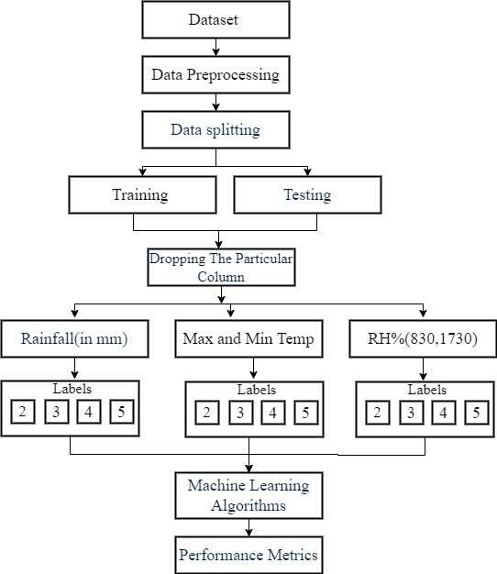

Fig.1 Algorithm for proposed Machine Learning Model

In this study, we used machine learning models to forecast meteorological characteristics such as rainfall, temperature, and relative humidity (RH%). The framework used multi-label categorization (2 to 5 labels) by removing various weather characteristics (rainfall, temperature, and relative humidity) and evaluated the model's performance. We ran independent forecasts for each deleted characteristic and compared the outcomes across models. The results for every weather parameter are as follows:

Rainfall Prediction (Dropping Rainfall): The Gaussian Process outperformed all other label predictions. Random Forest and Decision Tree produced similarly strong results, but hybrid models such as catboost + Logistic Regression performed moderately.

Temperature Prediction (with max and min temp): Catboost regularly outperformed all label predictions, although Decision Tree + Random Forest and Logistic Regression also produced good results. Hybrid models, such as XGBoost + KNN, performed inconsistently, particularly at smaller label counts.

RH% Prediction (Both RH%): The Gaussian Process produced excellent results across a variety of label counts. Hybrid models, such as catboost + Logistic Regression and xgboost + KNN, greatly increased prediction accuracy, especially for lower label predictions.

By systematically dropping one weather parameter at a time and predicting the others, we compared the performance of standalone and hybrid models, offering insights into how different algorithms perform under varying conditions. These results provide valuable insights into improving weather forecasting models.

Decision Tree: We tested the Decision Tree Classifier [12] by removing individual weather parameters (rainfall, temperature, RH%). The model adjusted its rules based on the available features, effectively predicting rainfall and RH% when specific parameters were missing.

Logistic Regression: We used Logistic Regression to classify rainfall into "low" and "high" categories. The model, trained on encoded categorical features, was evaluated with accuracy scores, classification reports, and confusion matrices.

Random Forest: We applied random forest to classify rainfall as "low" or "high." The model managed complex data patterns and was evaluated similarly with accuracy scores, classification reports, and confusion matrices.

XGBoost: It was used for binary classification of rainfall ("low" or "high"). Its performance, assessed through accuracy scores, classification reports, and confusion matrices, demonstrated its robust predictive capabilities.

Catboost: It was used for binary classification of rainfall (0 for no rain, 1 for rain). The model's performance was evaluated with accuracy ratings and classification reports, showing effective discrimination between rain and no rain.
Gaussian Process: The Gaussian Process Classifier was tested for binary classification, with performance evaluated through accuracy ratings, classification reports, and confusion matrices.

Catboost with Logistic Regression: We used a Stacking Classifier with catboost as the base estimator and Logistic Regression [13] as the final estimator. This model's performance, evaluated with accuracy scores and classification reports, demonstrated effective prediction of "Low" and "High" categories.

K-Nearest Neighbors (KNN) with xgboost: KNN and xgboost predictions were combined using majority voting. The combined model's effectiveness in classifying data into "low" and "high" was assessed with accuracy scores, classification reports, and confusion matrices.

Gaussian Process with Decision Tree: We combined Gaussian Process and Decision Tree classifiers [14] using majority voting. The combined model outperformed individual models in classifying data into "low" and "high."

Decision Tree and Random Forest: Combining Decision Tree and Random Forest classifiers [15] via majority voting proved effective in classifying data into "low" and "high" categories, as demonstrated by accuracy scores, classification reports, and confusion matrices.

Dataset
The Gannavaram Weather Dataset was compiled by the Gannavaram Weather Department, a reliable source of meteorological data for the Gannavaram region. This dataset covers a decade, from 2013 to 2023, and includes daily measurements of various crucial climatic indicators such as maximum and minimum temperatures, relative humidity at two different periods (8:30 AM and 5:30 PM), and daily rainfall. The data was collected using tight monitoring techniques to ensure accuracy and consistency, making it an invaluable resource for assessing long-term climate trends and seasonal changes in the region. To achieve robust modelling, the dataset was split 80:20 for analysis. Data from 2013 to 2021, accounting for 80% of the dataset, was set aside for training, with the remaining 20% saved for testing from 2022 to 2023. This extensive dataset has the potential to significantly improve weather forecasting accuracy and agricultural planning in Gannavaram.

Results
In our weather prediction model, we evaluated various algorithms to determine their effectiveness in predicting rainfall, temperature, and relative humidity by systematically dropping each weather parameter. The algorithms used included Decision Tree, Random Forest, Logistic Regression, XGBoost, Catboost, Gaussian Process, Catboost + Logistic Regression, XGBoost + KNN, Gaussian Process+ Decision Tree, and Decision Tree+ Random Forest. By analyzing the performance of The correlation matrix indicated that Max and Min Temperature are positively correlated (0.6566) but negatively correlated with Rainfall. RH% (830) has a moderate positive correlation with RH% (1730) and Rainfall, while showing a negative correlation with Max Temperature in Figure 2.

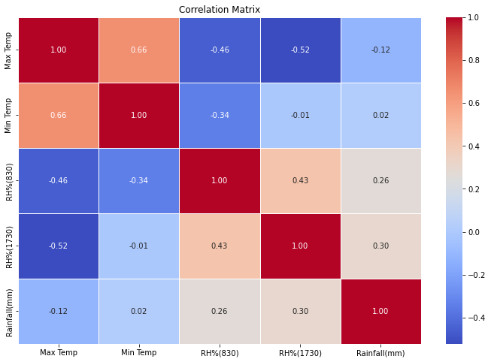

Fig-2: Correlation matrix of dataset variables

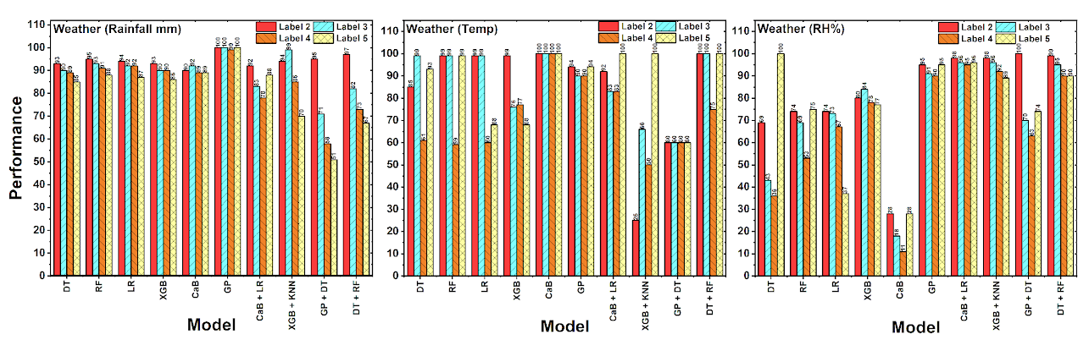

Fig-3. Labels impact over different machine learning algorithms

Figure 3 illustrates the impact of different machine learning algorithms across different labels from 2 to 5. When dropping the particular column for different labels we have different scenarios. In the three scenarios, we have dropped different columns like rainfall, temperature, and RH%. In each of the scenario, we have different evaluated the performance of our model. Gradient Boosting (GB) and Gaussian Process (GP) consistently perform best for the weather (Rainfall mm) parameter, reaching near-perfect scores close to 100% across all labels (Label 2, 3, 4, 5). Conversely, Logistic Regression (LR) has the lowest performance, achieving around 75% across all labels.
In figure 3 as for Weather (Temperature), XGBoost (XGB) is the best algorithm for all labels and has an accuracy of about 100%. In contrast, Logistic Regression (LR) has the lowest performance, yielding values ranging from 40% to 50%, signifying a notable decline in efficacy when measured against other models. XGBoost (XGB) and Random Forest (RF) show the best performance for Weather (Relative Humidity - RH%), with RF marginally outperforming XGB for Label 3 and both retaining excellent accuracy throughout additional labels. Still, with performance averaging about 45%, Logistic Regression (LR) yields the lowest outcomes in this instance. In these models

when individual parameters are removed, we aimed to understand how each algorithm handles the absence of temperature, rainfall, or relative humidity.

Conclusion
Our findings show that the Gaussian process model outperformed alternative models and hybrid techniques for weather prediction tasks, reaching 100% accuracy for both rainfall and temperature forecasts and high accuracy for relative humidity. This model's success can be ascribed to its strong handling of complicated data and ability to produce consistent results across varying label complexity. The Gaussian Process's high performance demonstrates its ability to manage complex data patterns. This model is the most effective option for achieving maximum accuracy in weather prediction jobs, particularly those using complex and multidimensional data. Furthermore, our complete strategy, which included a variety of models and configurations, considerably enhanced prediction accuracy and reliability, demonstrating superior weather forecasting tactics.

Acknowledgment
Thank you for providing us with real-time weather data from SRM University in Neerukonda. Accurate data from the Meteorological Centre Amaravati has been critical to our continuous study and analysis, considerably boosting the quality of our work.

References
- Mansfield, L. A., Nowack, P. J., Kasoar, M., Everitt, R. G., Collins, W. J., & Voulgarakis, A. (2020). Predicting global patterns of long-term climate change from short-term simulations using machine learning. Npj Climate and Atmospheric Science, 3(1), 44.
- Huntingford, C., Jeffers, E. S., Bonsall, M. B., Christensen, H. M., Lees, T., & Yang, H. (2019). Machine learning and artificial intelligence to aid climate change research and preparedness. Environmental Research Letters, 14(12), 124007.
- Zubaidi, S. L., Ortega-Martorell, S., Kot, P., Alkhaddar, R. M., Abdellatif, M., Gharghan, S. K., ... & Hashim, K. (2020). A method for predicting long-term municipal water demands under climate change. Water Resources Management, 34, 1265-1279.
- Alex, N., & Sobin, C. C. (2021, December). A method for weather forecasting using machine learning. In 2021 5th conference on information and communication technology (CICT) (pp. 1-6). IEEE.
- Shreemali, J., Galav, P., Kumawat, G., & Chittora, P. (2020). Rainfall Prediction for Udaipur Rajasthan Using Machine Learning Models Based on Temperature Vapour Pressure and Relative Humidity. International Journal of Recent Technology and Engineering, 8, 03.
- Jain, H., Dhupper, R., Shrivastava, A., Kumar, D., & Kumari, M. (2023). AI-enabled strategies for climate change adaptation: protecting communities, infrastructure, and businesses from the impacts of climate change. Computational Urban Science, 3(1), 25.
- Chen, L., Han, B., Wang, X., Zhao, J., Yang, W., & Yang, Z. (2023). Machine learning methods in weather and climate applications: A survey. Applied Sciences, 13(21), 12019.
- Anaraki, M. V., Farzin, S., Mousavi, S. F., & Karami, H. (2021). Uncertainty analysis of climate change impacts on flood frequency by using hybrid machine learning methods. Water Resources Management, 35, 199-223.
- Crane-Droesch, A. (2018). Machine learning methods for crop yield prediction and climate change impact assessment in agriculture. Environmental Research Letters, 13(11), 114003.
- Bochenek, B., & Ustrnul, Z. (2022). Machine learning in weather prediction and climate analyses—applications and perspectives. Atmosphere, 13(2), 180.
- H., Awadh, S. M., Salih, S. Q., Shafik, S. S., & Yaseen, Z. M. (2022). Integration of extreme gradient boosting feature selection approach with machine learning models: application of weather relative humidity prediction. Neural Computing and Applications, 34(1), 515-533.
- Hill, A. J., Schumacher, R. S., & Jirak, I. L. (2023). A new paradigm for medium-range severe weather forecasts: Probabilistic random forest–based predictions. Weather and Forecasting, 38(2), 251-272.
- Gupta, R., Yadav, A. K., Jha, S. K., & Pathak, P. K. (2024). Comparative analysis of advanced machine learning classifiers based on feature engineering framework for weather prediction. Scientia Iranica.
- Elbeltagi, A., Pande, C. B., Kumar, M., Tolche, A. D., Singh, S. K., Kumar, A., & Vishwakarma, D. K. (2023). Prediction of meteorological drought and standardized precipitation index based on the random forest (RF), random tree (RT), and Gaussian process regression (GPR) models. Environmental Science and Pollution Research, 30(15), 43183-43202.
- Masjkur, M., & Tan, K. S. (2019, August). Comparing decision tree, random forest and boosting in identifying weather index for rice yield prediction. In FM Afendi, K. Sadik, UD Syafitri (Ed.), Proceedings of the 1st International Conference on Statistics and Analytics, Bogor, Indonesia (pp. 454-463).

